 | 12.1.8 Editors - Geometry Nodes Editor - Header - Add Menu - Curve
Table of content
Detailed table of content 1
Add - Curve 6
Cuve Length 6
Cuve to Mesh 6
Cuve to Points 7
Deform Curves on Surface 8
Fill Curve 8
Fillet Curve 9
Resample curve 10
Reverse Curve 10
Sample Curve 11
Subdivide Curve 12
Trim Curve 13
Curve Handle Positions 14
Curve Tangent 14
Curve Tilt 14
Endpoint Selection 15
Handle Type Selection 15
Is Spline Cyclic 16
Spline Length 16
Spline Parameter 16
Spline Resolution 17
Set Curve Normal 17
Set Curve Radius 18
Set Curve Tilt 18
Set Handle Positions 19
Set Handle Type 19
Set Spline cyclic 20
Set Spline Resolution 21
Set Spline Type 21

Detailed table of content
Detailed table of content
Detailed table of content 1
Add - Curve 6
Cuve Length 6
Inputs 6
Curve 6
Outputs 6
Length 6
Cuve to Mesh 6
Inputs 6
Curve 6
Profile Curve 6
Fill Caps 7
Outputs 7
Mesh 7
Cuve to Points 7
Inputs 7
Curve 7
Properties 7
Mode 7
Evaluated 7
Count 7
Count Input 7
Length 7
Length Input 7
Outputs 7
Point 7
Tangent 8
Normal 8
Rotation 8
Deform Curves on Surface 8
Inputs 8
Curves 8
Outputs 8
Curves 8
Fill Curve 8
Inputs 8
Curve 8
Properties 8
Mode 8
Triangles or N-gons 8
Outputs 9
Mesh 9
Fillet Curve 9
Input 9
Curve 9
Count 9
Radius 9
Limit Radius 9
Properties 9
Mode 9
Bezier 9
Poly 9
Outputs 9
Curve 9
Resample curve 10
Input 10
Curve 10
Selection 10
Count 10
Length 10
Properties 10
Mode 10
Evaluated 10
Count 10
Length 10
Output 10
Curve 10
Reverse Curve 10
Inputs 11
Curve 11
Selection 11
Outputs 11
Curve 11
Sample Curve 11
Input 11
Curve 11
Value 11
Mode Factor 11
Factor 11
Curve Index 11
Mode Factor 11
Factor 11
Length 12
Properties 12
Data Type 12
Sample Curve Mode 12
All Curves 12
Output 12
Value 12
Position 12
Tangent 12
Normal 12
Subdivide Curve 12
Inputs 12
Geometry 12
Cuts 12
Outputs 13
Geometry 13
Trim Curve 13
Inputs 13
Curve 13
Start 13
End 13
Properties 13
Mode 13
Factor 13
Length 13
Outputs 14
Curve 14
Curve Handle Positions 14
Outputs 14
Left 14
Right 14
Curve Tangent 14
Outputs 14
Factor 14
Curve Tilt 14
Outputs 14
Tilt 14
Endpoint Selection 15
Input 15
Start Size 15
End Size 15
Outputs 15
Selection 15
Handle Type Selection 15
Properties 15
Left / Right 15
Handle Type 15
Output 15
Selection 15
Is Spline Cyclic 16
Outputs 16
Cyclic 16
Spline Length 16
Outputs 16
Length 16
Point Count 16
Spline Parameter 16
Outputs 17
Factor 17
Length 17
Index 17
Spline Resolution 17
Outputs 17
Resolution 17
Set Curve Normal 17
Input 17
Curve 17
Selection 17
Properties 17
Mode 17
Outputs 17
Curve 17
Set Curve Radius 18
Input 18
Geometry 18
Selection 18
Radius 18
Outputs 18
Geometry 18
Set Curve Tilt 18
Input 18
Geometry 18
Selection 18
Tilt 18
Outputs 18
Curve 18
Set Handle Positions 19
Input 19
Geometry 19
Selection 19
Position 19
Properties 19
Mode 19
Outputs 19
Geometry 19
Set Handle Type 19
Input 19
Curve 19
Selection 19
Properties 19
Mode 19
Handle Type 20
Free 20
Auto 20
Vector 20
Aligned 20
Output 20
Curve 20
Set Spline cyclic 20
Input 20
Geometry 20
Selection 20
Cyclic 21
Outputs 21
Geometry 21
Set Spline Resolution 21
Input 21
Geometry 21
Selection 21
Resolution 21
Outputs 21
Geometry 21
Set Spline Type 21
Input 21
Curve 21
Selection 21
Properties 22
Spline Type 22
Output 22
Curve 22

Add - Curve
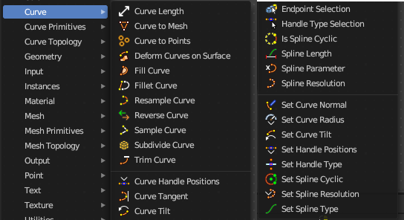
Here you find curve related nodes.

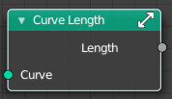
Cuve Length
Retreives the length of all splines added together.

Inputs

Curve
The input curve.

Outputs

Length
The length of the curve.

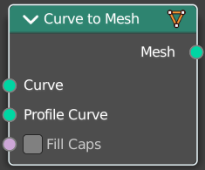
Cuve to Mesh
Converts a curve object to a mesh object. Optionally, a profile curve can be provided to give the curve a custom shape.

Inputs

Curve
The input curve.

Profile Curve
If a profile curve is provided, it will be extruded along all splines. Otherwise the generated mesh will just be a chain of edges.

Fill Caps
For cyclic profile curve. Fill the ends of the generated mesh for each spline combination with an N-gon.
The resulting mesh is Manifold, the two new faces for each spline are simply connected to existing edges.

Outputs

Mesh
Standard mesh output.

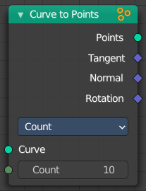
Cuve to Points
Converts a curve object to a Point cloud.

Inputs

Curve
The input curve.

Properties

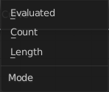
Mode
How to generate points from the input curve.

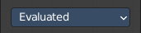
Evaluated
Create points from the evaluation points of the curve. This is based on the resolution attribute for nurbs and bezier splines.

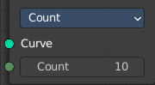
Count
Sample each spline by evenly distributing the specified number of points along the spline.

Count Input
The number of points to distribute along the spline.

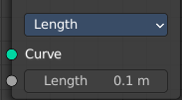
Length
Sample each spline by splitting the spline into segments by the specified length.

Length Input
The length of the single segments.

Outputs

Point
Generated point cloud.

Tangent
The normalized curve tangent at the sampled position, or the direct evaluated normal in Evaluated mode.

Normal
The normal value from the evaluated curve at each result point. This is the same value from the Normal Node at those positions.

Rotation
The Euler rotation build from the Tangent and Normal outputs.

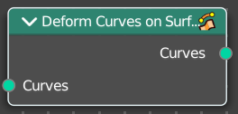
Deform Curves on Surface
Curves that are attached to a surface can follow the surface at modification.

Inputs

Curves
The input curve.

Outputs

Curves
The output curve.

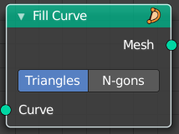
Fill Curve
Fills the curve with mesh geometry. The mesh is only generated flat with a local Z of 0.

Inputs

Curve
The input curve.

Properties

Mode

Triangles or N-gons
Fill the curve with either triangles, or use N-Gon geometry.

Outputs

Mesh
The output as mesh.

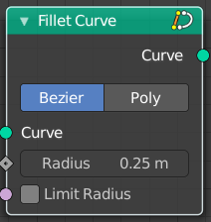
Fillet Curve
The Fillet Curve rounds corners on curve control points, similar to the effect of the Bevel Modifier on a 2D mesh.
A key difference is that the rounded portions created by the Fillet Curve node are always portions of a circle.

Input

Curve
The input curve.

Count
Polymode. Define the number of vertices that are created.

Radius
The radius of the arc

Limit Radius
Prevent overlapping when the defined radius exceeds the maximum possible radius for a given point.

Properties

Mode

Bezier
Creates a circular arc at vertices by changing handle lengths (applicable only for Bezier splines).

Poly
Creates a circular arc by creating vertices (as many as defined by the Count fields input) along the arc (applicable for all spline types).

Outputs

Curve
Standard geometry input with a curve component.

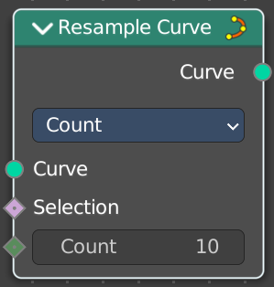
Resample curve
Creates a poly spline for each input spline. In the Count and Length modes, the control points of the new poly splines will have uniform spacing.

Input

Curve
The input geometry.

Selection
A selection of the input geometry

Count
The number of control points on the new splines.

Length
The approximate length between the control points of the new splines.

Properties

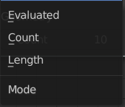
Mode
The resample mode.

Evaluated
Use the resolution attribute for spline and bezier curves.

Count
Use the count of the curve points.

Length
Use the length of the curve.

Output

Curve
Standard geometry output.

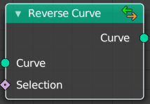
Reverse Curve
Reverses the direction of the spline. The start point becomes the end point and vice versa. The shape of the spline is not modified.

Inputs

Curve
The input curve.

Selection
An optional selection attribute to determine which part of the spline should be reversed.

Outputs

Curve
Standard geometry output.

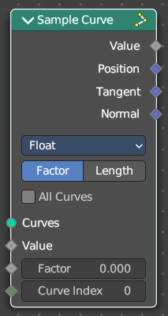
Sample Curve
Calculates a point on a curve at a certain distance from the start of the curve, specified by the length or factor inputs. It also outputs data retrieved from that position on the curve.
The sampled values are linearly interpolated from the values at the evaluated curve points at each side of the sampled point.
In case that the curve contains multiple splines, the sample position is found based on the total accumulated length, including the lengths of all previous splines. The order of the splines is the same order as displayed in the Spreadsheet Editor.

Input

Curve
The input geometry.

Value
Input Value.

Mode Factor

Factor
The resample amount with method Factor.

Curve Index
The curve index.

Mode Factor

Factor
The resample amount with method Factor.

Length
The resample amount with method Length.

Properties

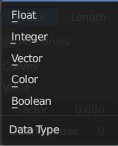
Data Type
What data to calculate.

Sample Curve Mode
How to calculate the curve. By a factor, or by its length.

All Curves
Sample lengths based on the length of all curves.

Output

Value
Output Value.

Position
The position at the sample along the spline.

Tangent
The normalized curve tangent at the sample.

Normal
The normalized curve normal at the sample.

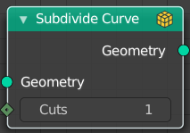
Subdivide Curve
Subdivides the curve. The shape is not changed.

Inputs

Geometry
The input curve.

Cuts
The number of cuts per segment.

Outputs

Geometry
Standard geometry output.

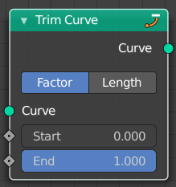
Trim Curve
The Curve Trim node shortens each spline in the curve by removing sections at the start and end of each spline.
Bézier splines will still output as Bézier splines. The first and last control point and its handles will be moved as necessary to preserve the shape. But NURBS splines will be transformed into poly splines in order to be trimmed.
Cyclic splines are currently not supported.
Note that if the Start input is larger than the End, then the resulting spline will have a single point, located at the sample location of the Start value.

Inputs

Curve
Standard geometry input with a curve component.

Start
The factor or length used to determine where to start each output spline.

End
The factor or length used to determine where to end each output spline.

Properties

Mode
How to find endpoint positions for the trimmed spline.

Factor
The endpoint positions of each spline’s length is determined by a factor. The input values should be between 0 or 1.

Length
The endpoint positions of each spline is determined by a length from the start of each spline. The input values should be between 0 and the length of the splines.

Outputs

Curve
Standard geometry output.

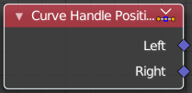
Curve Handle Positions
Get the position of the left or right handle of a curve point.

Outputs

Left
The left handle of the curve point.

Right
The right handle of the curve point.

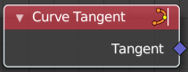
Curve Tangent
Retreive the tangent direction of a curve. The output values are normalized vectors.
Note that for NURBS and Bézier spline curves the value retrieved from this node is the value at every control point, which may not correspond to the visible evaluated points. For NURBS splines the difference may be even more pronounced and the result may not be as expected. A Resample Curve Node node can be used to create a poly spline, where there is a control point for every evaluated point.

Outputs

Factor
The vector of the tangent.

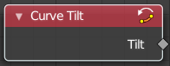
Curve Tilt
Outputs the angle used to turn the curve normal around the direction of the curve tangent in its evaluated points.
The output is per control point. For NURBS and Bézier splines, the values will be interpolated to the final evaluated points.

Outputs

Tilt
The tilt angle for the normal in radians.

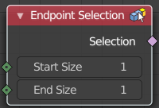
Endpoint Selection
The Endpoint Selection node allows for the Selection of an aribitrary
number of endpoints from each spline in a curve. The start and end
inputs are evaluated on the spline domain. The result is outputted
as a boolean field on the point domain.

Input

Start Size
The start point of the spline.

End Size
The end point of the spline.

Outputs

Selection
Selection output.

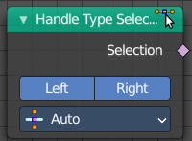
Handle Type Selection
Creates a selection based on the handle types of the control points.

Properties

Left / Right
Wether to check for the type of handles.

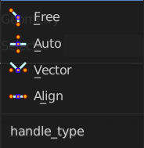
Handle Type
What handle type to compare.

Output

Selection
The selection.

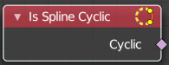
Is Spline Cyclic
Retreive if the curve is set to cyclic.

Outputs

Cyclic
If the spline is cyclic or not.

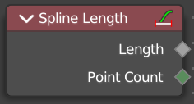
Spline Length
Retreive the total length of each spline in a curve.

Outputs

Length
The length of each spline in the curve.

Point Count
Integer Field input of the number of control points on each spline in the spline domain. Or in the point domain, it is the number of points on the spline that contains the given control point.

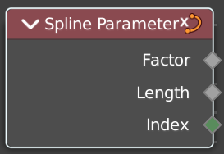
Spline Parameter
The Curve Parameter node outputs how far along each spline a control point is, with a value between zero and one. The output is different from dividing the index by the total number of control points, because the control points might not be equally spaced along the curve.
The first value is zero, so the output corresponds to the length at the control point rather than including the length of the following segment.

When used on the spline domain, the node outputs the portion of the total length of the curve (including all splines) has been traversed at the start of each spline. The order of the curve’s splines is visible in the Spreadsheet Editor.
Note that for NURBS and Bézier spline curves the value retrieved from this node is the value at every control point, which may not correspond to the visible evaluated points. For NURBS splines the difference may be even more pronounced and the result may not be as expected. A Resample Curve Node node can be used to create a poly spline, where there is a control point for every evaluated point.

Outputs

Factor
The factor of the curve.

Length
The length of the curve.

Index
The index of the curve.

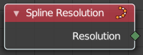
Spline Resolution
Retreive the curve resolution. Means the number of spline points.

Outputs

Resolution
The spline resolution.

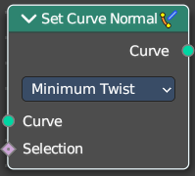
Set Curve Normal
Set the evaluation mode for curve normals.

Input

Curve
The input curve.

Selection
A selection of the input curve.

Properties

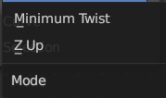
Mode
The evaluation mode for the curve normals.

Outputs

Curve
The curve output.

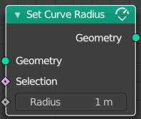
Set Curve Radius
Set the curve radius.

Input

Geometry
The input curve.

Selection
A selection of the input curve.

Radius
The radius to set.

Outputs

Geometry
Standard geometry output.

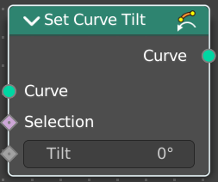
Set Curve Tilt
Controls the tilt angle at each curve control point.

Input

Geometry
The input curve.

Selection
Whether or not to change the value on each control point. True values mean the value will be changed, false values mean the value will remain the same.

Tilt
The tilt rotation.

Outputs

Curve
Standard geometry output.

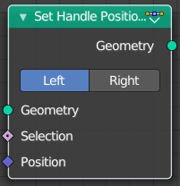
Set Handle Positions
Set the handle positions of bezier curves

Input

Geometry
The input curve.

Selection
A selection of the input curve.

Position
The position of the handle.

Properties

Mode
Left or right handles.

Outputs

Geometry
Standard geometry output.

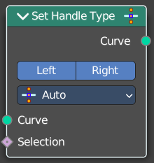
Set Handle Type
Sets a handle type for the curve points of a bezier curve. Handle types determines how the interpolation before and after the curve point happens.

Input

Curve
The input curve.

Selection
A selection of the input curve.

Properties

Mode
Left or right handles.

Handle Type
The different available handle types.

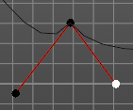
Free
The handles can be adjusted individually.

Auto
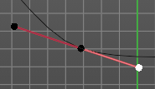
The left and the right handle will always point to each other. The length of the handles will start in equal size.

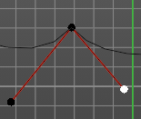
Vector
The handles can be adjusted individually.

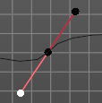
Aligned
The left and the right handle will always point to each other.

Output

Curve
Standard geometry output.

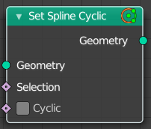
Set Spline cyclic
Sets the spline cyclic. Means looping.

Input

Geometry
The input curve.

Selection
A selection of the input curve.

Cyclic
Cyclic or not

Outputs

Geometry
Standard geometry output.

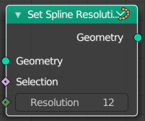
Set Spline Resolution
Sets the resolution of the spline. Means how many evaluated points should be generated on the curve for each control point.

Input

Geometry
The input curve.

Selection
A selection of the input curve.

Resolution
The resolution of the spline.

Outputs

Geometry
Standard geometry output.

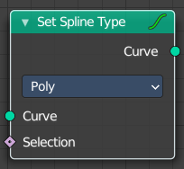
Set Spline Type
Change the curve spline type.

Input

Curve
The input curve.

Selection
A selection of the input curve.

Properties

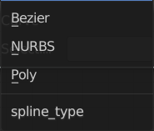
Spline Type
The spline type to set the curve to.
Note that when converting from a NURBS spline to a Bézier spline, at least six points are needed. When the number of points is not a multiple of three a full conversion is not possible and the spline has to be truncated.

Output

Curve
Standard geometry output.

